Capstone Project Milestone

Project Title

Systematic Comparison of Deep Learning Architectures and Training Strategies for Crop Disease Detection

Team Members
Manisha Chaudhary and Roshan Saud

Problem Statement
Crop diseases remain one of the leading causes of agricultural losses, reducing yields by up to 40% worldwide and posing serious threats to food security. Farmers often lack timely access to expert pathologists, leading to delayed interventions. While deep learning has shown impressive results in plant disease detection, most studies focus either on single architecture or benchmark datasets without systematically examining how model choice and training strategies interact under controlled conditions.
Our project addresses this gap by comparing two widely used architectures ResNet50 and EfficientNet-B4 under identical datasets and evaluation frameworks. Beyond architectural differences, we also explore how training strategies (batch size, optimizer type, and number of epochs) affect performance while fixing the learning rate for consistency. This dual-level evaluation balances algorithmic accuracy with practical deployment concerns such as efficiency, inference speed, and suitability for resource-limited agricultural settings.
By generating comparative benchmarks and optimization insights, this project will provide an empirical understanding of architecture performance and effective training strategies for crop disease detection. If time permits, we will further demonstrate the applicability of our best-performing model by developing a simple web application for disease prediction.

Research Focus
- Architectural Comparison: Which architecture ResNet50 or EfficientNet-B4 delivers superior classification accuracy, efficiency, and inference speed on crop disease datasets under controlled conditions?

- Training Strategy Evaluation: How do variations in batch size, optimizer (e.g., Adam, SGD), and training epochs influence model performance, and which configurations balance accuracy with computational efficiency?

Literature Review
Early work (Mohanty et al., 2016) demonstrated the feasibility of CNNs for plant disease detection with near-perfect accuracies on controlled datasets. Since then, ResNet architectures have gained popularity for their residual learning ability, enabling deep networks to train effectively. On the other hand, EfficientNet architectures (Tan & Le, 2019) leverage compound scaling of depth, width, and resolution, offering an improved accuracy-efficiency tradeoff and making them promising for resource-constrained environments.
Recent studies (Sujatha et al., 2025; Zhang et al., 2024) confirm that EfficientNet variants outperform traditional CNNs in terms of efficiency, while transfer learning has emerged as the dominant approach for agricultural AI (Kumar et al., 2024). However, most prior work either evaluates a single architecture or fails to keep experimental conditions constant, making direct comparisons challenging. Moreover, hyperparameter choices are often reported without systematic exploration, leaving open questions about how training strategies affect final performance in practice. This project fills that gap by offering a controlled architectural comparison and a systematic evaluation of training strategies.

Current Progress and Next Step
Since the project proposal submission on September 19, we have made significant progress in data organization, preprocessing setup, and experimental planning. The dataset was downloaded, inspected, and cleaned to ensure one-to-one consistency between image files and labels. Missing or mismatched records were removed, and a filtered dataset containing approximately 18,000 valid images was prepared. A structured folder system for training, validation, and testing data has been created for seamless data loading. This part has been explained in the 7.1 Dataset and preprocessing section.
Additionally, research was conducted on the model to understand their architecture explained in 7.2 Model architecture. Moreover, a preprocessing pipeline compatible with both ResNet-50 and EfficientNet-B4 has been established, including image resizing, augmentation, and normalization using ImageNet statistics. The training configuration and hyperparameter search space have been finalized placed in the section 7.2.1, and the codebase is fully prepared for training experiments scheduled in upcoming weeks (Weeks 5–7). Trial experiment has been done once for each model to get preliminary outputs.
A jupyter notebook file containing codes and results have been also attached as a part of submission.
The following activities will be completed as per the original project schedule:
  - Week 5-7: Continue train ResNet-50 with all hyperparameter variations and record training logs.
  - Week 5–7: Continue train EfficientNet-B4 using identical hyperparameters for fair comparison.
  - Week 8-10: Conduct comparative evaluation of both architectures using accuracy, precision, recall, and confusion matrices, report writing and finalization.

Methodology

Exploratory Data Analysis and Preprocessing
The dataset was obtained from Kaggle website (link: https://www.kaggle.com/datasets/mexwell/crop-diseases-classification). The dataset was in combination of three forms i.e RBG images, CSV file format and JSON file. Exploratory Data Analysis (EDA) was conducted to understand the dataset composition, class distribution, and image characteristics before model training. From the analysis we found that, the data structure was in such a way that RGB images were renamed to specific image labels that corresponds specific numeric label like 0, 1, 2, 3, 4 and these labels were mapped to class name 0: Cassava Bacterial Blight (CBB), 1: Cassava Brown Streak Disease (CBSD), 2: Cassava Green Mottle (CGM), 3: Cassava Mosaic Disease (CMD), 4: Healthy in the JSON file.
As the first part of EDA and preprocessing we map corresponding numeric label to their name with the image label in a pandas dataframe and simultaneously got total count of the records in the dataframe which was 21397. Later stage the total number of images were also counted which was found to 17938, which showed that there were few thousand images missing. Therefore, 3459 rows were removed from the dataframe those were missing their corresponding images and the dataframe was saved as a CSV file for later use.
In the next step, data augmentation was applied to enhance the diversity of the training dataset. The original images were size 800×600 which were later resized into 224×224 to get the optimum image size considering both ResNet50 and EfficientNetB4 model. Then, images were rotated, flipped, and adjusted for contrast and brightness to better simulate real-world data collection scenarios. To maintain consistency, specific ranges for rotation angles, brightness, and contrast variations were defined, along with corresponding probabilities to control the likelihood of each augmentation being applied to an image. The processed sample images are shown in Figure 1.
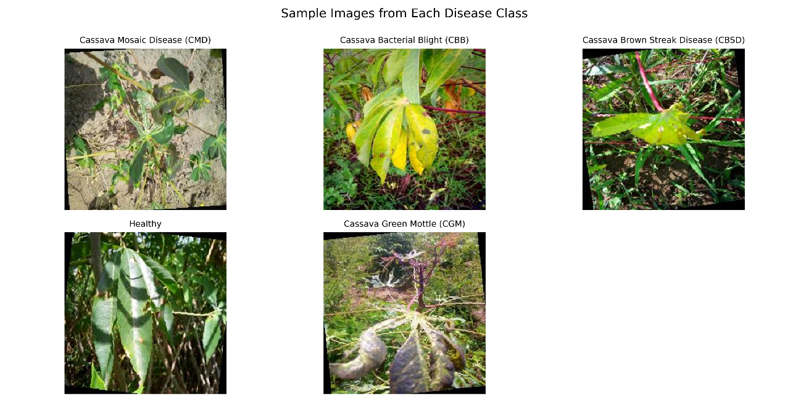
Fig 1. Representative images from each class after preprocessing. Classes vary in texture and color complexity.
In the third preprocessing step, the finalized CSV file was used to create training, testing, and validation datasets. Upon examining the class distribution, it was observed that the dataset was heavily dominated by one specific class. This distribution is visualized in the Figure 2 barchart below. In figure 2 we can see that the dataset exhibits a noticeable class imbalance, with Cassava Mosaic Disease (CMD) having the highest representation, followed by Healthy i.e healthy leaves, Cassava Green Mottle (CGM), while Cassava Brown Streak Disease (CBSD) and Cassava Bacterial Blight (CBB), were relatively underrepresented. This imbalance was intentionally retained to evaluate how both architectures handle skewed class distributions under realistic conditions.
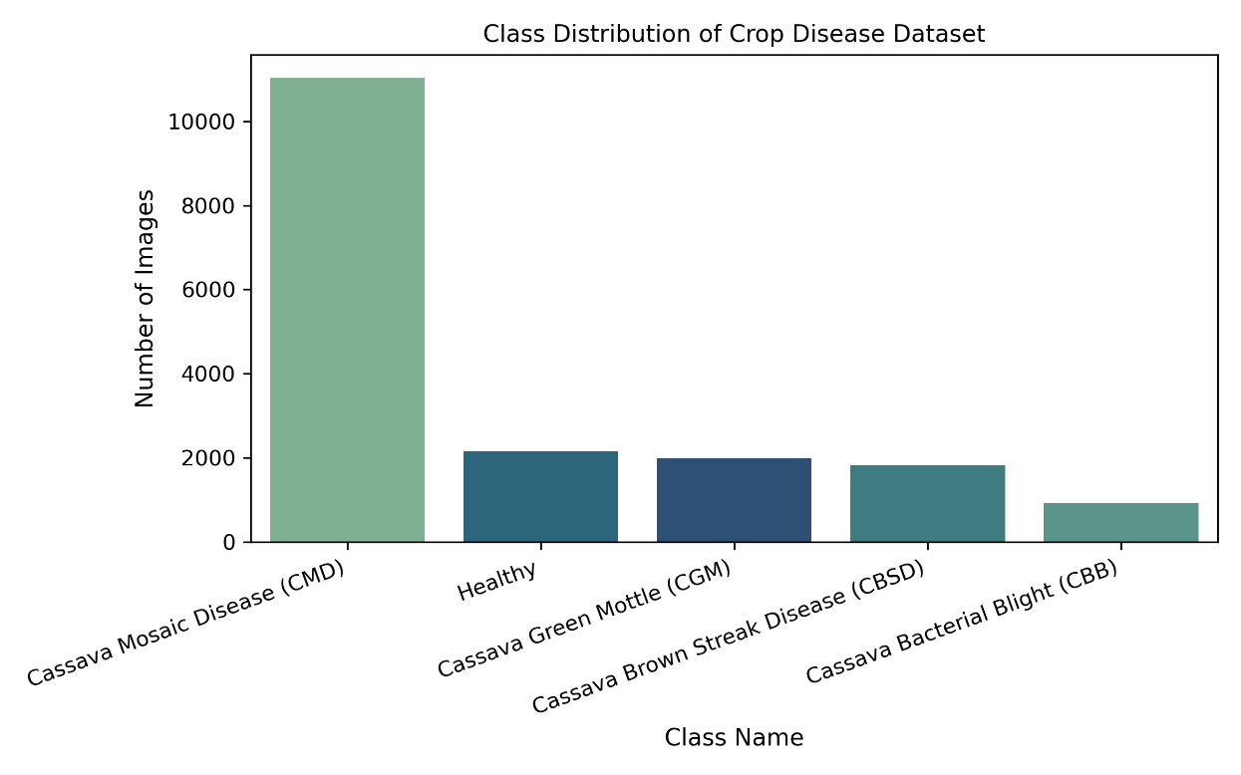
Fig 2. Class distribution across the five crop disease categories showing dataset imbalance dominated by Cassava Mosaic Disease (CMD).
Hence, filtered dataset was spit in such a way that the train, test and validation dataset maintains the ratio of the input dataset. We end up having 13453 instances for train, 2691 for validation and 1794 instances for test datasets. Each corresponding image was placed in the separate folders to avoid the confusion and reduce the chances of mixing of dataset.

Model Architectures
- ResNet50: ResNet-50 is a 50-layer deep residual network, was selected as the baseline model for this study. It was pre-trained on the ImageNet dataset and will be fine-tuned for our five-class classification task by replacing the final fully connected layer. ResNet’s skip (residual) connections allow gradient information to propagate effectively through many layers, mitigating the vanishing-gradient problem that limits traditional CNNs beyond ~20 layers. This architecture provides a strong, well-established benchmark for transfer learning tasks and serves as the baseline for comparative analysis.

- EfficientNet-B4: EfficientNet-B4 was chosen as the advanced model because it balances network depth, width, and image resolution in an efficient way. This balanced design, known as compound scaling, allows the model to achieve high accuracy with fewer parameters compared to other CNNs. It is built with modern layers called MBConv and Squeeze-and-Excitation (SE) blocks, which help the network focus on the most important image features. The model was also pre-trained on ImageNet and will also be fine-tuned for our five-class classification task by replacing its final classifier layer.

Training Strategy
To ensure a fair and consistent comparison, both ResNet-50 and EfficientNet-B4 will be trained using three distinct parameter configurations derived from recent literature on CNN fine-tuning and transfer learning. Each configuration varies the learning rate, batch size, optimizer, and regularization strength to evaluate their influence on convergence and generalization performance. The chosen settings were informed by prior studies such as Kaur et al. (2025), Ali et al. (2025), and Ansari et al. (2024), which demonstrated effective transfer learning performance under similar hyperparameter conditions.
These parameter combinations were also carefully selected to represent configurations suited for small to moderately large datasets. Lower batch sizes and higher learning rates (e.g., Adam with batch size 16–32) help stabilize gradients and accelerate learning for smaller datasets, while larger batch sizes with lower learning rates (e.g., SGD with batch size 64) provide smoother convergence and improved generalization for larger datasets. This balanced design allows both architectures to be evaluated under conditions that reflect realistic training scenarios across different data scales.
SN | Learning Rate | Batch Size | Optimizer | Regularization | Epoch | References
1 | 0.001 | 32 | Adam | Weight Decay 1e‑4,  Dropout 0.3 | 40–50 | (Kaur et al., 2025), (Ali et al., 2025)
2 | 0.0005 | 64 | SGD + Momentum 0.9 | Weight Decay 5e‑5, Dropout 0.25 | 60 | (Ansari et al., 2024)
3 | 0.001 | 16 | AdamW | Weight Decay 1e−5, Dropout 0.25 | 30 | (Wu et al., 2024)

Preliminary Results

References
- Ali, H., Shifa, N., Benlamri, R., Farooque, A. A., & Yaqub, R. (2025). A fine-tuned EfficientNet-B0 convolutional neural network for accurate and efficient classification of apple leaf diseases. Scientific Reports, 15(1), 25732. https://doi.org/10.1038/s41598-025-04479-2
- Ansari, M. M., Kumar, S., Tariq, U., Belal Bin Heyat, M., Akhtar, F., Bin Hayat, M. A., Sayeed, E., Parveen, S., & Pomary, D. (2024). Evaluating CNN Architectures and Hyperparameter Tuning for Enhanced Lung Cancer Detection Using Transfer Learning. Journal of Electrical and Computer Engineering, 2024(1), 3790617. https://doi.org/10.1155/2024/3790617
- Dahiphale, D., Shinde, P., Patil, K., & Dahiphale, V. (2023). Smart Farming: Crop Recommendation using Machine Learning with Challenges and Future Ideas. https://doi.org/10.36227/techrxiv.23504496.v1
- Dash, Ritesh, et al. “Classification of Crop Based on Macronutrients and Weather Data Using Machine Learning Techniques.” Results in Engineering, vol. 9, Mar. 2021, p. 100203, https://doi.org/10.1016/j.rineng.2021.100203. Accessed 24 May 2021
- Hughes, D., & Salathé, M. (2016). An open access repository of images on plant health to enable the development of mobile disease diagnostics. arXiv preprint arXiv:1511.08060.
- Kaur, H., Sharma, R., & Kaur, J. (2025). 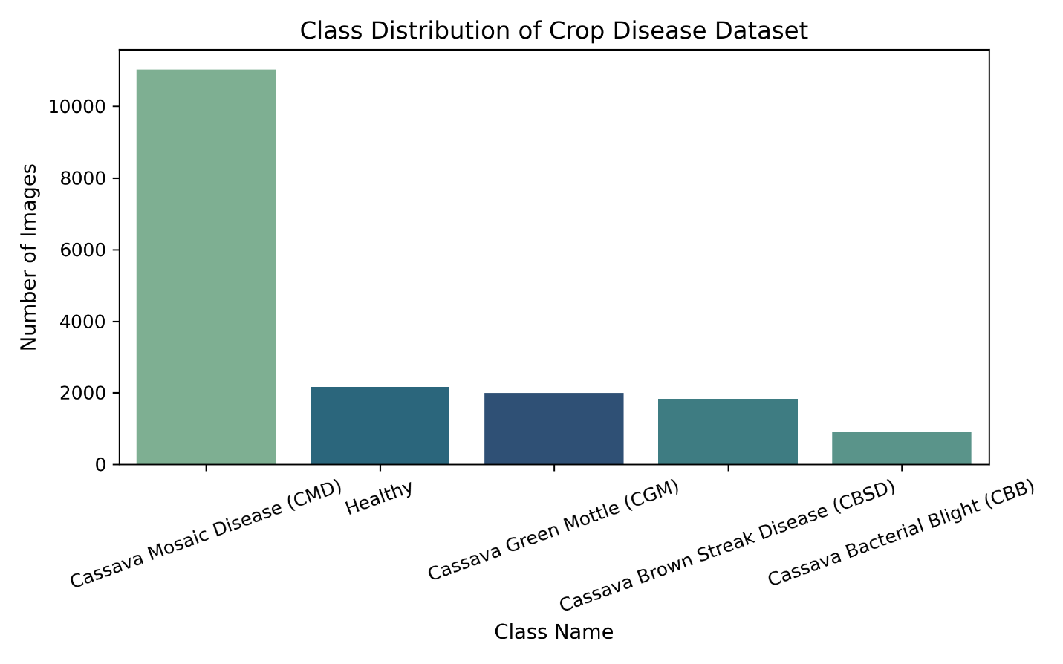Comparison of deep transfer learning models for classification of cervical cancer from pap smear images. Scientific Reports, 15(1), 3945. https://doi.org/10.1038/s41598-024-74531-0
- Kumar, S., Patel, N., & Gupta, A. (2024). Deep learning approaches for plant disease classification with attention mechanisms. Frontiers in Plant Science, 15, 1452551.
- Mohanty, S. P., Hughes, D. P., & Salathé, M. (2016). Using deep learning for image-based plant disease detection. Frontiers in Plant Science, 7, 1419.
- Nisar, K., & Goncharov, I. (2023, January 29). Maximize Agriculture Yield. W&B. https://wandb.ai/agriculture-hackathon-wandb/crop-prediction/reports/Maximize-Agriculture-Yiel d---Vml ldzoxNjIxMDQ4
- Sujatha, R., Krishnan, S., Chatterjee, J. M., & Hassanien, A. H. (2025). Advancing plant leaf disease detection integrating machine learning and deep learning. Scientific Reports, 15, 2271.
- Sharma, A., Kumar, P., & Singh, R. (2025). An efficient plant disease detection using transfer learning approach. Scientific Reports, 15, 14021.
- Wu, Z., Zhuo, R., Liu, X., Wu, B., & Wang, J. (2024). Enhancing surgical decision-making in NEC with ResNet18: A deep learning approach to predict the need for surgery through x-ray image analysis. Frontiers in Pediatrics, 12, 1405780. https://doi.org/10.3389/fped.2024.1405780
- Yash Gupta & Garima Srivastava. (2024). Crop recommendation system for growing best suitable crop. International Journal of Science and Research Archive, 12(1), 2928–2936. https://doi.org/10.30574/ijsra.2024.12.1.1111
- Zhang, L., Wang, M., & Chen, H. (2024). Advancing plant leaf disease detection integrating machine learning and deep learning. Scientific Reports, 14, 72197.

